MYSQL QUERIES

**SOCIAL MEDIA ENGAGEMENT**

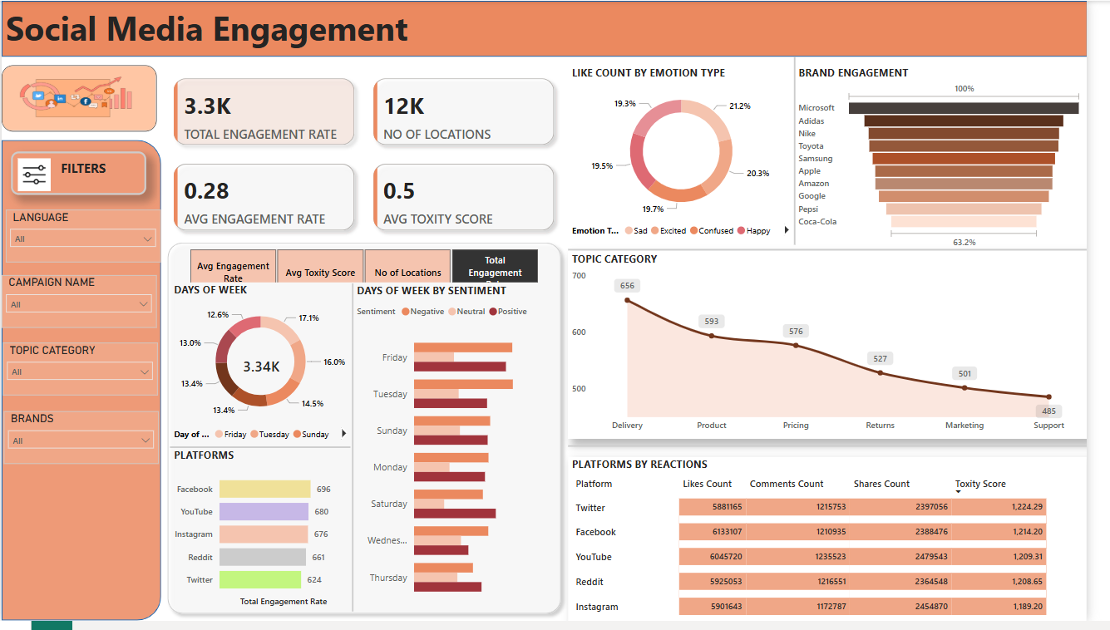

1. **Total Engagement Rate**

SELECT

CONCAT(ROUND(SUM(`Engagement Rate`)/1000 , 1),'K') AS total_engagement_rate

FROM social_media_engagement;

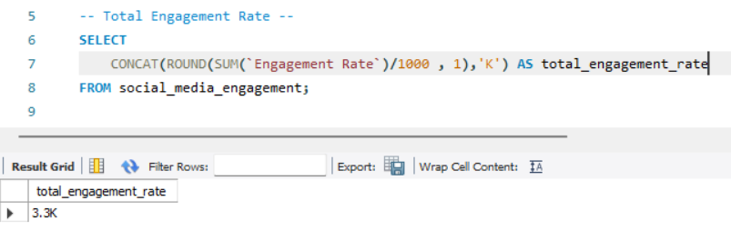

1. **Number of Locations**

SELECT

CONCAT(ROUND(SUM(`Engagement Rate`)/1000 , 1),'K') AS total_engagement_rate

FROM social_media_engagement;

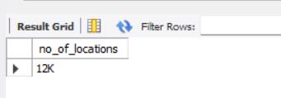

1. **Average Engagement Rate**

SELECT

ROUND(AVG(`Engagement Rate`), 2) AS avg_engagement_rate

FROM social_media_engagement;

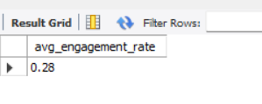

1. **Average Toxcity Score**

SELECT

ROUND(AVG(`Toxity Score`), 2) AS avg_toxity_score

FROM social_media_engagement;

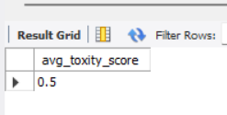

1. **Like Count by Emotion Type**

SELECT

`Emotion Type`,

ROUND(

100 * SUM(`Likes Count`) / (SELECT SUM(`Likes Count`) FROM social_media_engagement),

2

) AS likes_count

FROM social_media_engagement

GROUP BY `Emotion Type`;

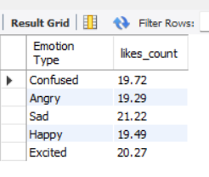

1. **Brand Engagement**

SELECT

`Brand Name`,

ROUND(SUM(`Engagement Rate`), 2) AS total_engagement

FROM social_media_engagement

GROUP BY `Brand Name`

ORDER BY total_engagement DESC;

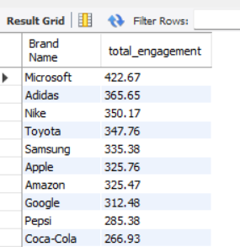

1. **Days of Week by Sentiment**

SELECT

`ï»¿Day of Week`,

`Sentiment Label`,

ROUND(SUM(`Engagement Rate`), 2) AS total_engagement

FROM social_media_engagement

GROUP BY `ï»¿Day of Week`, `Sentiment Label`;

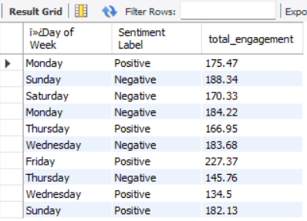

1. **Platforms**

-- Likes per Platform

SELECT Platform, SUM(`Likes Count`) AS value FROM social_media_engagement GROUP BY Platform;

-- Shares per Platform

SELECT Platform, SUM(`Shares Count`) AS value FROM social_media_engagement GROUP BY Platform;

-- Comments per Platform

SELECT Platform, SUM(`Comments Count`) AS value FROM social_media_engagement GROUP BY Platform;

-- Avg Toxity Score per Platform

SELECT Platform, ROUND(AVG(`Toxity Score`), 2) AS value FROM social_media_engagement GROUP BY Platform;

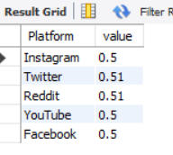

1. **Topic Category**

SELECT

`Topic Category`,

ROUND(SUM(`Engagement Rate`), 2) AS total_engagement

FROM social_media_engagement

GROUP BY `Topic Category`

ORDER BY total_engagement DESC;

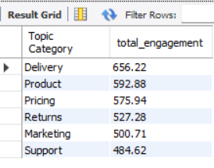

1. **Platforms By Reactions**

SELECT

Platform,

SUM(`Likes Count`) AS total_likes,

SUM(`Shares Count`) AS total_shares,

SUM(`Comments Count`) AS total_comments,

ROUND(AVG(`Toxity Score`), 2) AS avg_toxity_score

FROM social_media_engagement

GROUP BY Platform;

